

**Du Lich Do Day Software Architecture**

**Project Code: #01**

**Document Code: Architecture Design– v1.0**

**< >**

Internal use

**RECORD OF CHANGE**

*A - Added M - Modified D - Deleted

|  |  |  |  |  |
| --- | --- | --- | --- | --- |
| **Effective Date** | **Changed Items** | **A* M, D** | **Change Description** | **New Version** |
| 19/03/2018 | First vesion | A | N/A | 1.0 |
|  |  |  |  |  |
|  |  |  |  |  |
|  |  |  |  |  |
|  |  |  |  |  |
|  |  |  |  |  |
|  |  |  |  |  |
|  |  |  |  |  |
|  |  |  |  |  |
|  |  |  |  |  |
|  |  |  |  |  |
|  |  |  |  |  |
|  |  |  |  |  |
|  |  |  |  |  |
|  |  |  |  |  |
|  |  |  |  |  |

**SIGNATURE PAGE**

|  |  |  |
| --- | --- | --- |
| **ORIGINATOR:** | Hoang Van Nghiep  <Position> | 19/03/2018 |
| **REVIEWERS:** | <Name>  <Position> | <Date> |
|  | <Name, if it’s needed>  <Position> | <Date> |
| **APPROVAL:** | <Name>  <Position> | <Date> |

**TABLE OF CONTENTS**

1 INTRODUCTION 5

1.1 Purpose 5

2 ARCHITECTURAL WORK FLOW 5

# INTRODUCTION

This document provides information about how the application works.

## Purpose

This document provides a comprehensive architectural overview of the system, using a number of different architectural views to depict different aspects of the system. It is intended to capture and convey the significant architectural decisions that have been made on the system.

# ARCHITECTURAL WORK FLOW

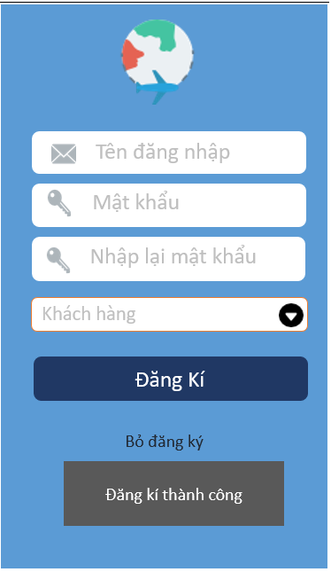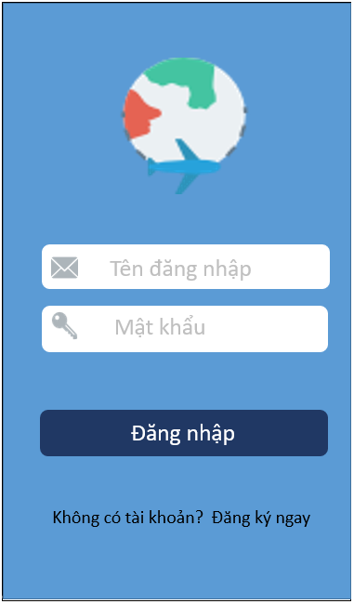#1. The login screen #2. The registration screen

Select Register now

Completion and click the subscribe button

Press the login button

Confirm the correct username and password

#3 The main screen

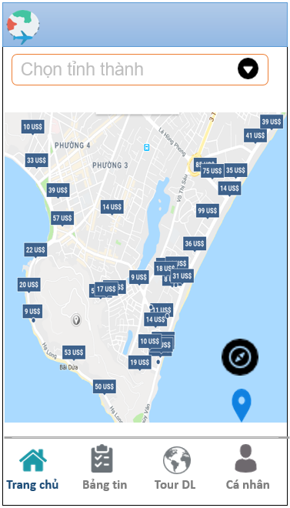#3 The main screen Location around here

Select province want to search destinations

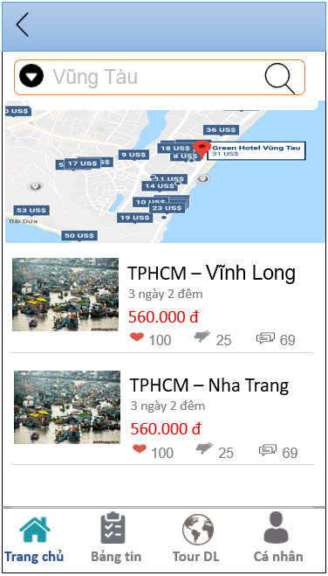

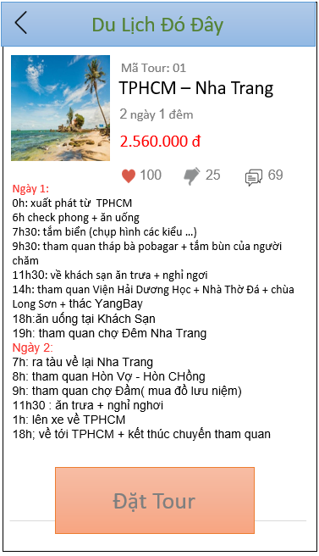

Click Select tour

Click the screen back home

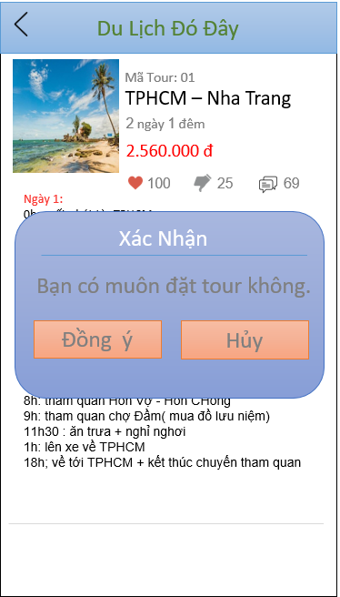 #4. Tour details Confirmation of tour

Select Cancel hide menu.

Select the most recent tour will show the confirm table

Select Back back tour

Click Select tour

#5. Screen Tour Du Lich

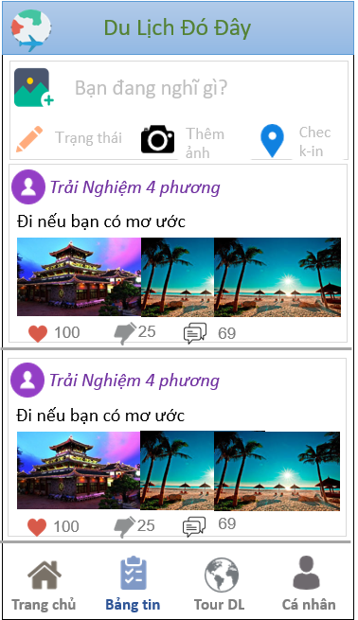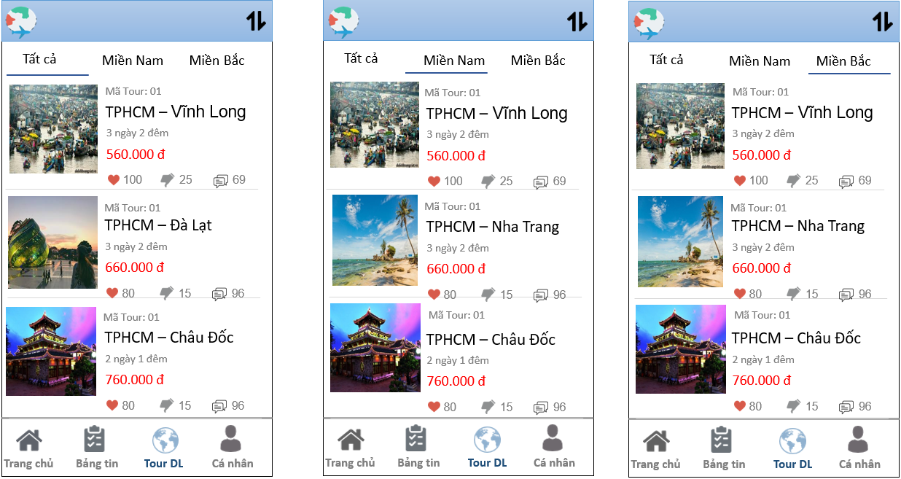 #5. Screen Tour Du Lich

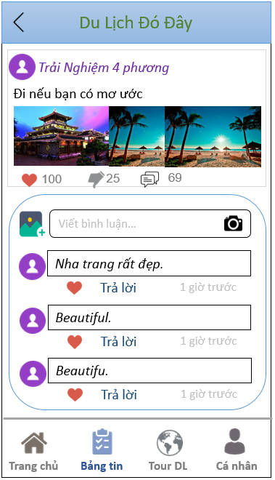 #6. Screen message board The comment screen message board

Click the back button to return to the message board

Select the comment icon

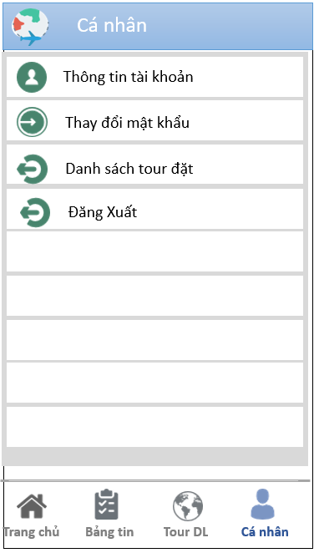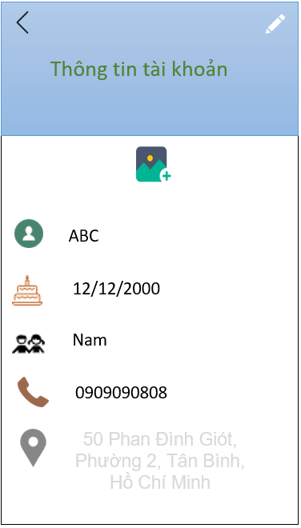

#7. Personal Page screen #8. The account information page

Choose to view your personal information

Press back the screen ca entertainment

Update successful

Select Edit Info

#9. The screen updated account information

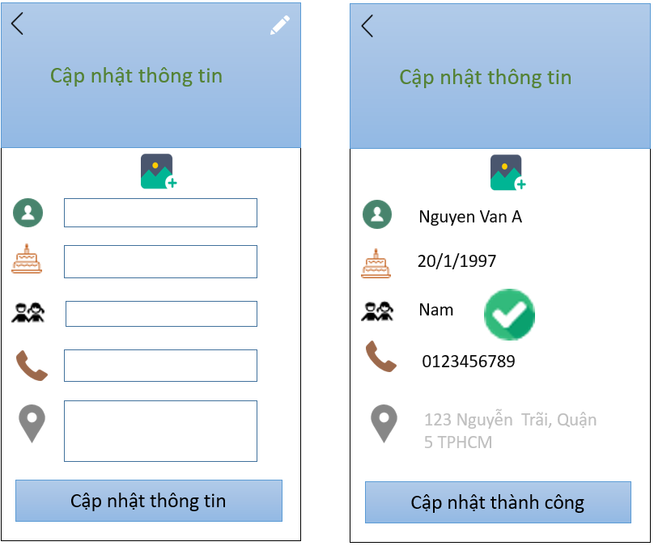

#10. Personal page screen #11. The change password screen

Select change password

Choose the exit button to return. Select agree to update the information in the account data

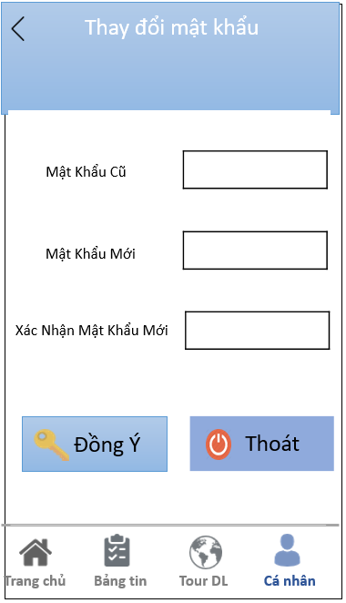

Select back back to the ca personnel screen

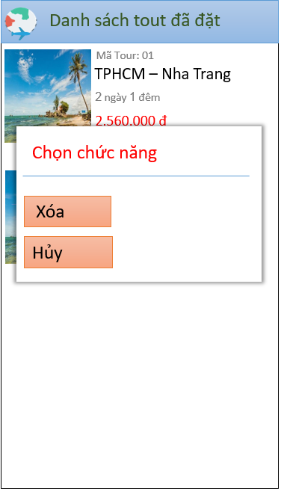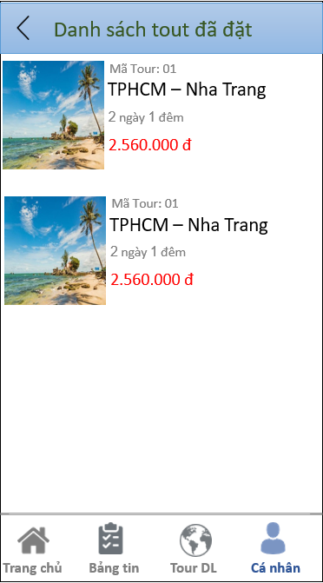#12. The tour was named listings screen. Select a function in the list screen tour has put

Select Cancel, or press the back button

Hold on 1 tour to show menu

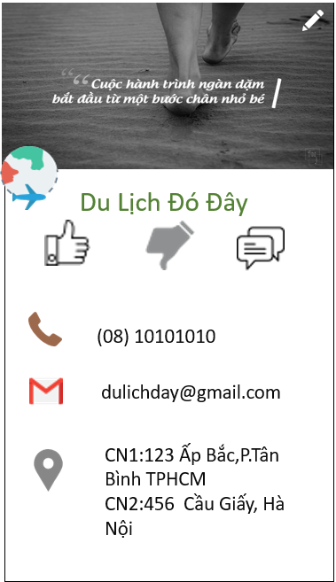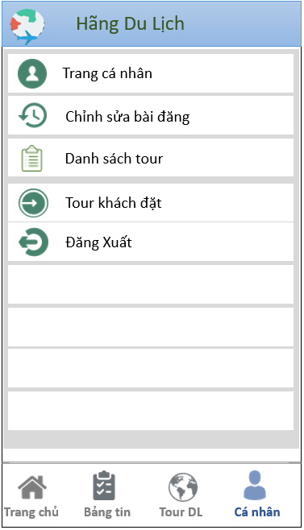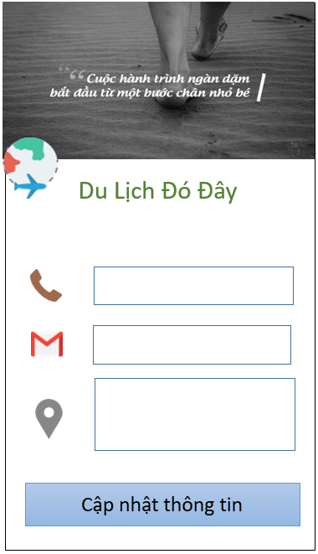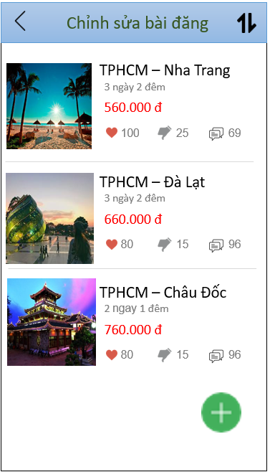 #13. Business page screen #14. Business information screen

Select Edit this post

Back

Select view personal page

Select the back button

Select back. or to confirm and update information stored data

Click on the pen to edit information

#16. The edit post screen #15. The screen update information

Click Cancel.

Or clear the tour and updated list tour

More success or select back

Hold on 1 tour show menu

Select the button Add new tour

#18. More screen tour #17. Edit menu tour

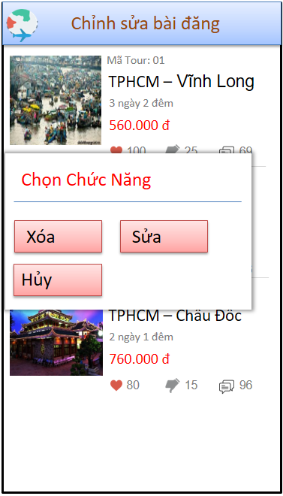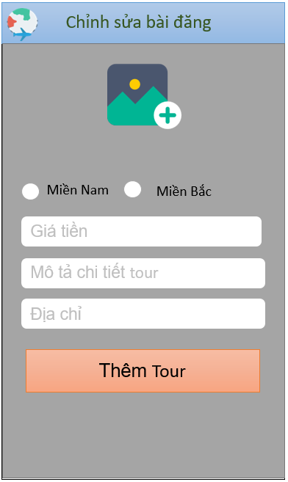#18. More screen tour #17. Edit menu tour

Select this page tour

#19. Information editing screen postings #16 list of tour

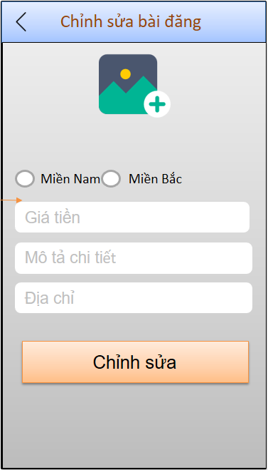

This page is successful or press back

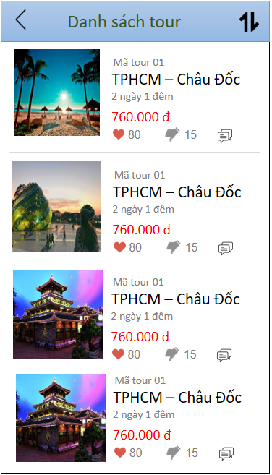#13. Business page screen #20. Tour list screen

Select view tour list

Select back

Select back

Select view tour reservation

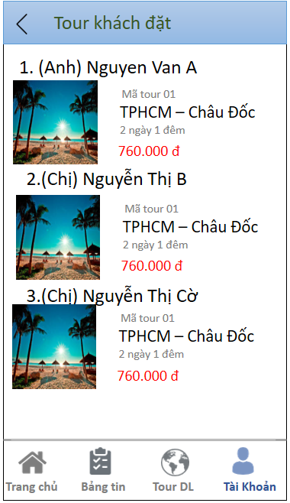#20. List of tour bookings